# CS 255 System Design Document Template

This template lays out all the different sections that you need to complete for Project Two. Each section has guidance to prompt your thinking. You will need to continually reference the interview transcript as you work to make sure that you are addressing your client’s needs. There is no required length for the final document. Instead the goal is to complete each section based on what your client’s needs are. Remove this note when you are finished, and replace all bracketed text with the relevant information.

## UML Diagrams

### UML Use Case Diagram

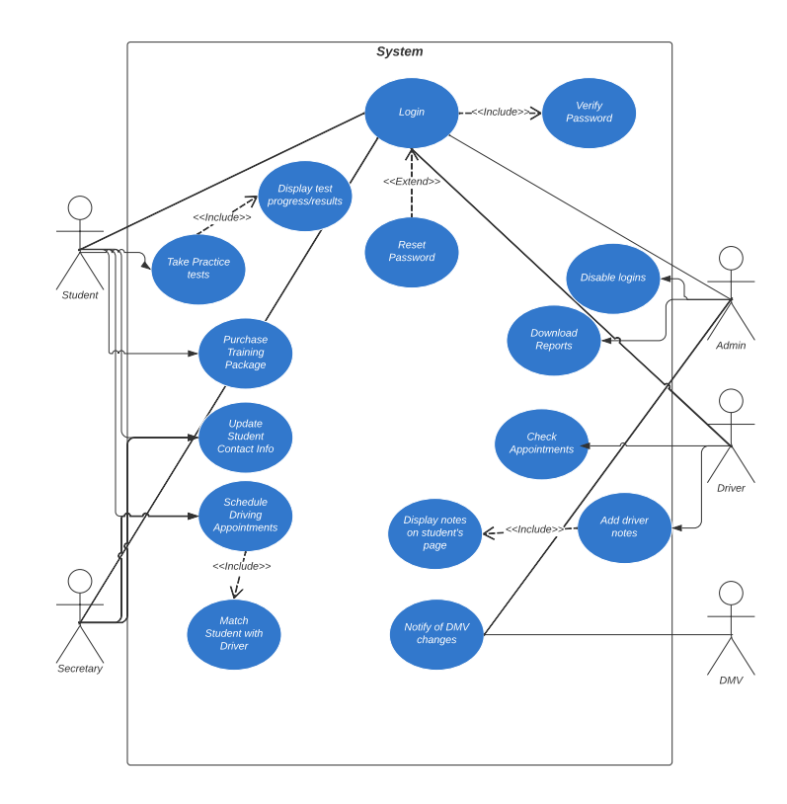

### UML Activity Diagrams

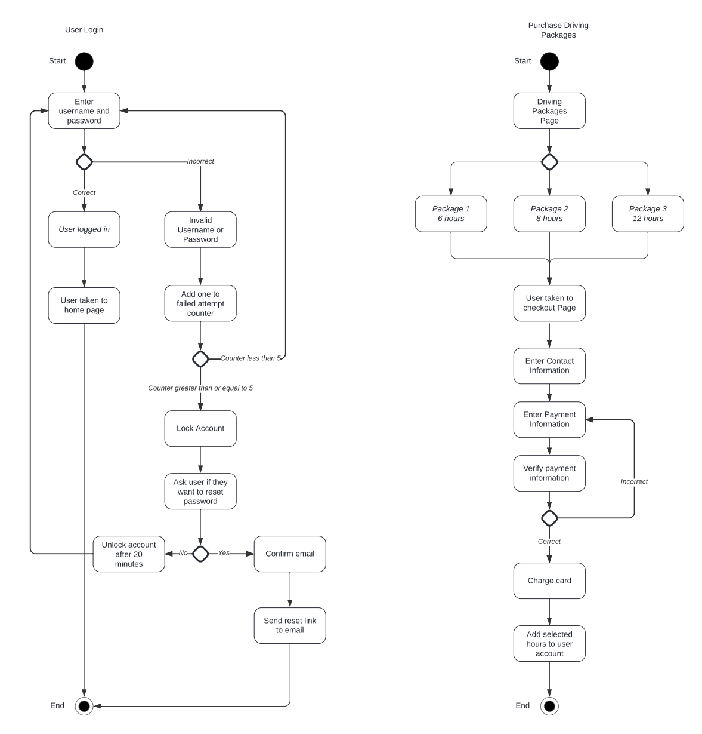

### UML Sequence Diagram

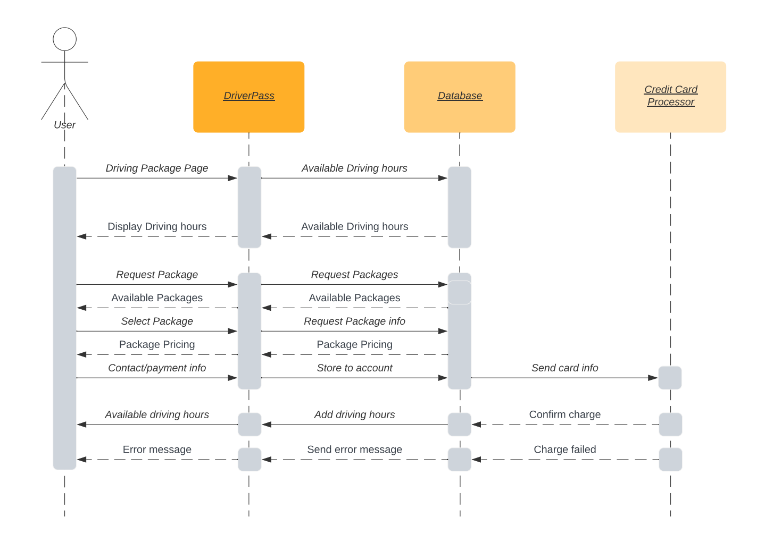

### UML Class Diagram

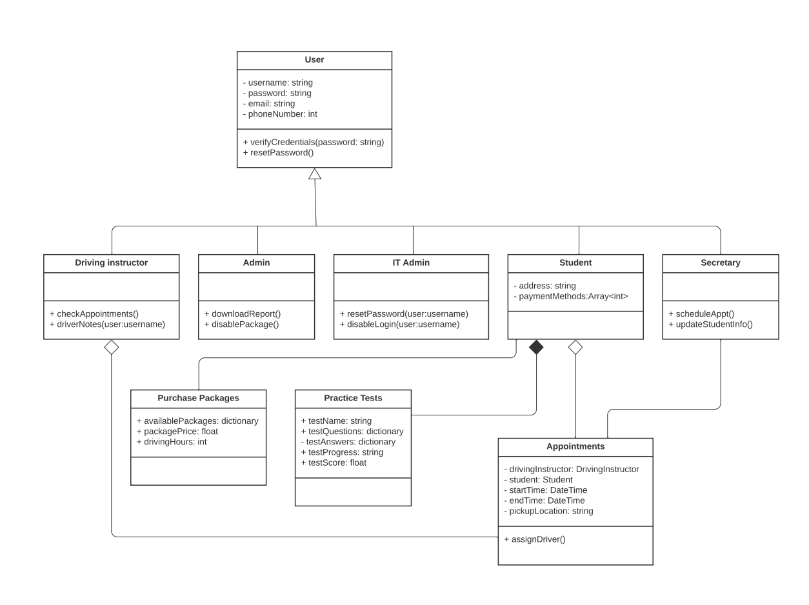

## Technical Requirements

*The DriverPass system is a web-based application that will run over a cloud-based hosting service. This database will store necessary information to the system. A stable internet connection will be required as well as a device such as a computer with a web browser to access the interface for the staff and customers. Payment processing services will be required to run payments from customer credit cards.*